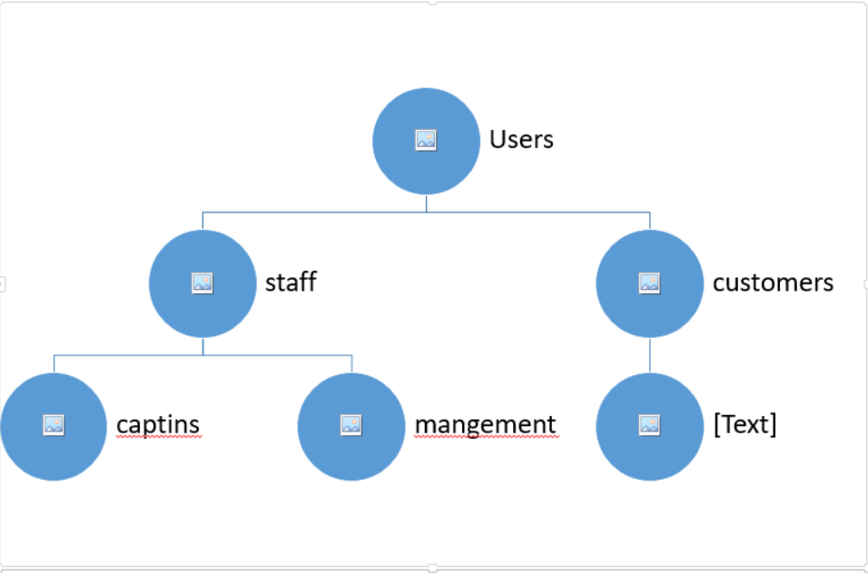

UserTypes

(UserType_ID, UserType_Name)

Users:

(User_ID, Username, password, email, phoneNo, UserType_ID, isActive)

User_Address:

(ID, USER_ID, isDefault, REMARKS, LOCATION_LAT, LOCATION_LONG, CITY, REGION, DISTRICT, BUILDING NO, STREET_NAME, APARTMENT_NO, FLOOR _NO)

Permissions

(Permission_ID, Permission_Name, Permission_Description, Permission_CanBeAssigned)

UserPermissions

(ID, UserType_ID, Permission_ID)

Staff

(User_ID, Title_ID, Hiring_Date, Hiring_End_Date, File_Info, isBlocked, STAFFType)

STAFF_TYPES

(STAFFType_ID, STAFFTYPE_Name)

Title

(Title_ID, Title_Name, Title_Grade)

STAFF_SALARY

(ID, STAFF_ID, SALARY, isActive, START_DATE)

Captain

(User_ID, )

CAPTAIN_RATE

(ID, ORDER_ID, RATE)

CATAIN_VEHICAL

(ID, NAME, TYPE, MODEL, LICENCE_NO, LICENCE_VALIDAITY, VEHICAL_SEQ_NO, CAPTAIN_ID)

CATAIN_LICENCE

(ID, TYPE, LICENCE_NO, LICENCE_VALIDAITY, CAPTAIN_ID)

SEVERITY

(ID, SEVERITY_NAME, SEVERITY_RANK, DESCRIPTION, ACTION_TO_UNBLOCK, PROCEDURES_TO_FOLLOW, SEVERITY_TYPE)

PENALITY

(ID, NAME, DESCRIPTION, SEVERITY_ID)

PRE-DEFINED_REASONS

(ID, NAME, DESC)

PENALITY_REASON

(ID, PENALITY_ID, REASON_ID)

STAFF_REASON

(ID, User_ID, REASON_ID, DATE_TIME, EFFECTIVE_DATE, END_DATE_TIME, ORDER_ID)

Customers:

(Id, Fname, LName, username, password, email, phoneNO)

ItemCategories

(id, categories, Description, ParentId)

Item

(id, name,)

Itemprices

(id, itemId,Price,datetime)

Order

(id, OrderIssuedDatetime,Customerid,status, OrderArrivalDatetime, captinid )

Orderstatus

(id,staus)

OrderDetails

(id, ordered, itemid, price )

periodType

(Id, Type)

Periods

(id, DateFrom, DateTo, periodType)

CustComplains

(id, custid, Complaintype, status, complaindescription, complainstatus,orderid)

Captinscomplains

(id, captinid, Complaintype, status, complaindescription, complainstatus,orderid,)

Note, All audit data and tracking excluded